**Title**

***A report submitted in partial fulfilment of the***

***requirement for the award of degree of***

***BACHELORS OF ENGINEERING***

***in***

***CSE in Information Security***

***Submitted By***

**Yanshu Kishore – 1 (19BCS3508)**

**Tanmay Rastogi – 2 (19BCS3534)**

**Pavitra Bhagat– 3 (19BCS3532)**

***Under the guidance of***

**Mr. Anshul Sharma**

**Mr. Divneet Singh Kapoor**

**Mr. Khushal Thakur**

**Assistant Professors, Academic Unit – 1**



**Academic Unit-1**

**UIE, Chandigarh University**

**Table of Contents**

List of Figures………………………………………………… 3

List of Tables…………………………………………………. 4

Abstract……………………………………………………….. 5

Chapter 1. Problem Identification……………………………. 6

Chapter 2. Feature Finalization……………………………….. 7

Chapter 3. Design Flow………………………………………. 8

Chapter 4. Simulation and outcome…………………………... 9-10

Chapter 5. Conclusion and future scope……………………… 11

References (If Any) …………………………………………… 12

Cost Analysis………………………………………………….. 13

Archives Project Submission Form…………………………… 14

List of Figures

Figure 1.1: Block Diagram 1.1…………………………………...8

Figure 1.2: Circuit Diagram 2.1………………………………….9

Figure 2.1: Circuit Diagram 2.2………………………………….9

Figure 4.1: Project lifecycle 3.1………………………………….9

Figure 4.1: Project lifecycle 3.2………………………………….10

Figure 4.1: Project lifecycle 3.3………………………………….10

Figure 4.1: Project lifecycle 3.4………………………………….10

Figure 4.1: Project lifecycle 3.5………………………………….10

**List of Tables**

Table 1.1: Financial summary1.1…………………………………………13

Table 2.1: Team members 2.1……………………………..………………14

**Abstract**

*In Almost every place, Fire is present on stoves running on LPG, a highly flammable gas which if leaks and combusts out of desire can bring serious fatalities. The main problem being leaking of LPG from any single point of failure in the system and igniting undesirably.*

*The solution is to detect the leakage of the gas and alert the people in the household to safely and timely stop the leakage hence preventing any major casualties and, hence saving countless lives.*

# 

# Chapter 1

**Problem Identification**

*To identify the problem, we can look at some cases:*

***Case 1:*** *The Connector valve Fitting is either damaged or loose resulting in gradual LPG leak. This is a result of careless and frequent usage of the regulator or wearing of the pipe. Even if one turns off the stove and the regulator, the gas can easily leak and cause accidents.*

***Case 2:*** *In old and rural households the stove and the gas cylinder are often kept on the ground in open. Their children during playing can unknowingly turn on the stove and cause the gas to leak.*

***Case 3:*** *In today’s busy schedule people often forget to turn off the stove or the regulator which can cause unwanted leakage of LPG.*

*These cases clearly show the damage and fatalities caused by gas leak incidents and why there is a need for such devices in the market at reasonable prices.*

# Chapter 2

**Feature finalization**

***Capabilities:***

1. *It can detect LPG irrespective of the source. For example: it can detect the gas leaking from the stove as well as from the regulator and the valve in time such that no significant amount of gas is leaked before alerting the user.*
2. *It alerts the user by a beeping sound through the buzzer.*
3. *It also alerts the user by LED Indicator Light in case of leakage.*
4. *It Provide the intensity of gas leaking through the app.*
5. *App alert the user by SMS, Notification and Calling to pre-Programmed number.*

***Limitations:***

1. *Our project requires on a Bluetooth abled device.*

# Chapter 3

**Design Flow**

**Block Diagram**

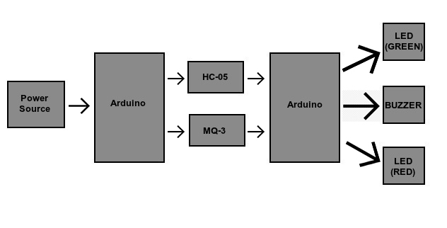

**Materials**

PRODUCT SPECIFICATION QUANTITY

1. MQ-3 GAS SENSOR 01

2. Arduino MICROCONTROLLER BOARD 01

3. Buzzer AUDIO SIGNALLING DEVICE 01

4. LED LIGHT-EMITTIND DIODE 02

5. HC-05 BLUETOOTH MODULE 01

# Chapter 4

**Simulation and Outcome**

**Circuit Diagram**

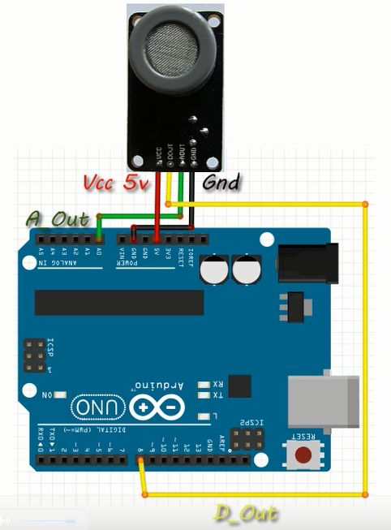

**Project lifecycle**

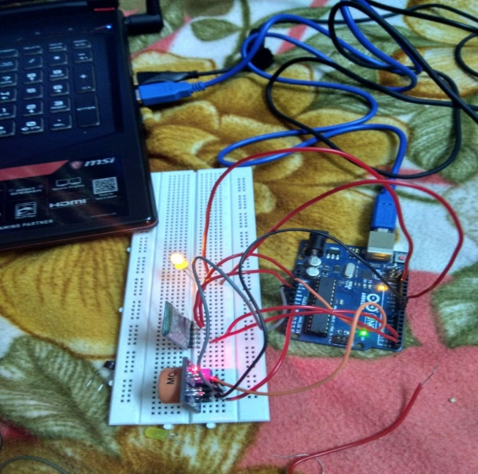

Testing the connection of Arduino, HC- 05, MQ-03, LED and Buzzer.

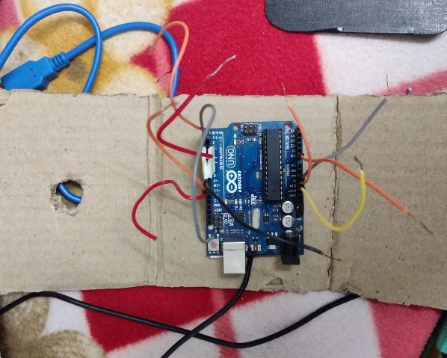

# Making Connection of VCC,Ground and Programmable pins with Arduino and jumper wire.

# 

# Making Connection with MQ-03 and HC-05.

*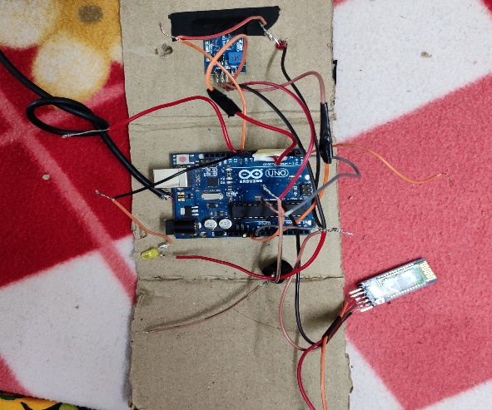***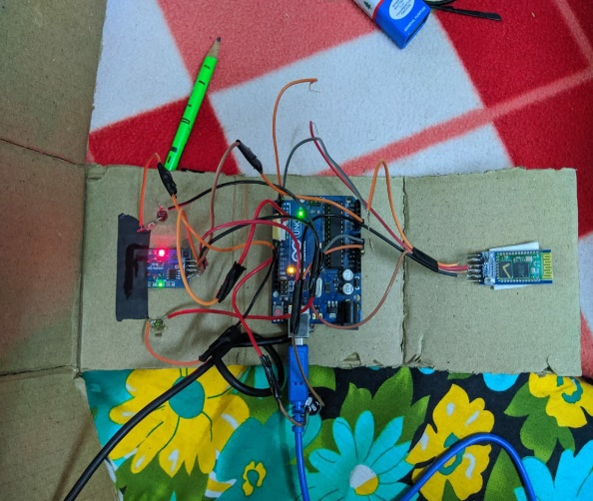**

Packing the All setup in closed box while checking all connections.

Checked all connection and packed the component in closed box.

# Chapter 5

**Conclusion and Future Scope**

The Device will ensure the safety of people in the Household as well as the property from any damage.

This type of device should be used in every household as well as restaurants and places where such flammable substances are stored or worked upon.

This device should also be implemented in storage facilities where such gasses are stored to prevent the collateral damages which are the result of such accidents.

**Future Scope:**

1. Planned for automatic sense and adding feature of smart home.
2. Planned to connect it to Voice Based Assistant.
3. Planned to make Cloud based system/

**References**

1. **MQ3 -** [**http://wiki.seeedstudio.com/Grove-Gas_Sensor-MQ3**](http://wiki.seeedstudio.com/Grove-Gas_Sensor-MQ3)
2. **BUZZER -** [**https://en.wikipedia.org/wiki/Buzzer**](https://en.wikipedia.org/wiki/Buzzer)
3. **LPG -** [**http://www.academia.edu/Documents/in/LPG**](http://www.academia.edu/Documents/in/LPG)
4. **GAS Detector -** [**https://en.wikipedia.org/wiki/Gas_detector**](https://en.wikipedia.org/wiki/Gas_detector)
5. **HC-05 -** [**https://wiki.eprolabs.com/index.php?title=Bluetooth_Module_HC-05**](https://wiki.eprolabs.com/index.php?title=Bluetooth_Module_HC-05)
6. **MIT App Inventor 2 -** [**http://ai2.appinventor.mit.edu**](http://ai2.appinventor.mit.edu)
7. **MIT App Inventor tutorials -** [**https://appinventor.mit.edu/explore/ai2/tutorials**](https://appinventor.mit.edu/explore/ai2/tutorials)

**Cost Analysis**

**Materials**

PRODUCT SPECIFICATION QUANTITY

1. MQ-3 GAS SENSOR 01

2. Arduino MICROCONTROLLER BOARD 01

3. Buzzer AUDIO SIGNALLING DEVICE 01

4. LED LIGHT-EMITTED DIODE 02

5. HC-05 BLUETOOTH MODULE 01

6. Wires Connection between components 20

**Financial summary**

|  |  |  |  |
| --- | --- | --- | --- |
| **S. No.** | **Component / Material/Services** | | **Price (in Rs.)** |
| 1. | MQ-03 | | 149 |
| 2. | Arduino | | 600 |
| 3. | Buzzer | | 35 |
| 4. | LED | | 10 |
| 5. | HC-05 | | 280 |
| 6. | Wires | | 25 |
| **Total** | | **1099** | |

**ARCHIVES PROJECT SUBMISSION FORM**

Project Code: **CU/Aug-2019/Sem____/UID______________ (To be filled by Office)**

Project Name: ________________________________________

Team Members:

|  |  |  |  |  |
| --- | --- | --- | --- | --- |
| **S. No.** | **Name** | **UID** | **Semester** | **Contact No.** |
| 1. |  |  |  |  |
| 2. |  |  |  |  |
| 3. |  |  |  |  |
| 4. |  |  |  |  |
| 5. |  |  |  |  |

**Section to be filled by team leader**

**Status (Please tick, whichever applicable)**

|  |  |  |  |
| --- | --- | --- | --- |
| Working |  | Not Working |  |

Team leader Details:

Name _______________________________ UID ______________________

Sign ________________________________ Date ______________________

**Section to be filled by Project Examiner(s)**

**Status (Please tick, whichever applicable)**

|  |  |  |  |
| --- | --- | --- | --- |
| Working |  | Not Working |  |

Project Examiner Signatures:

Internal _______________________________ Employee ID ______________

External _______________________________ Employee ID ______________

Date __________________________________